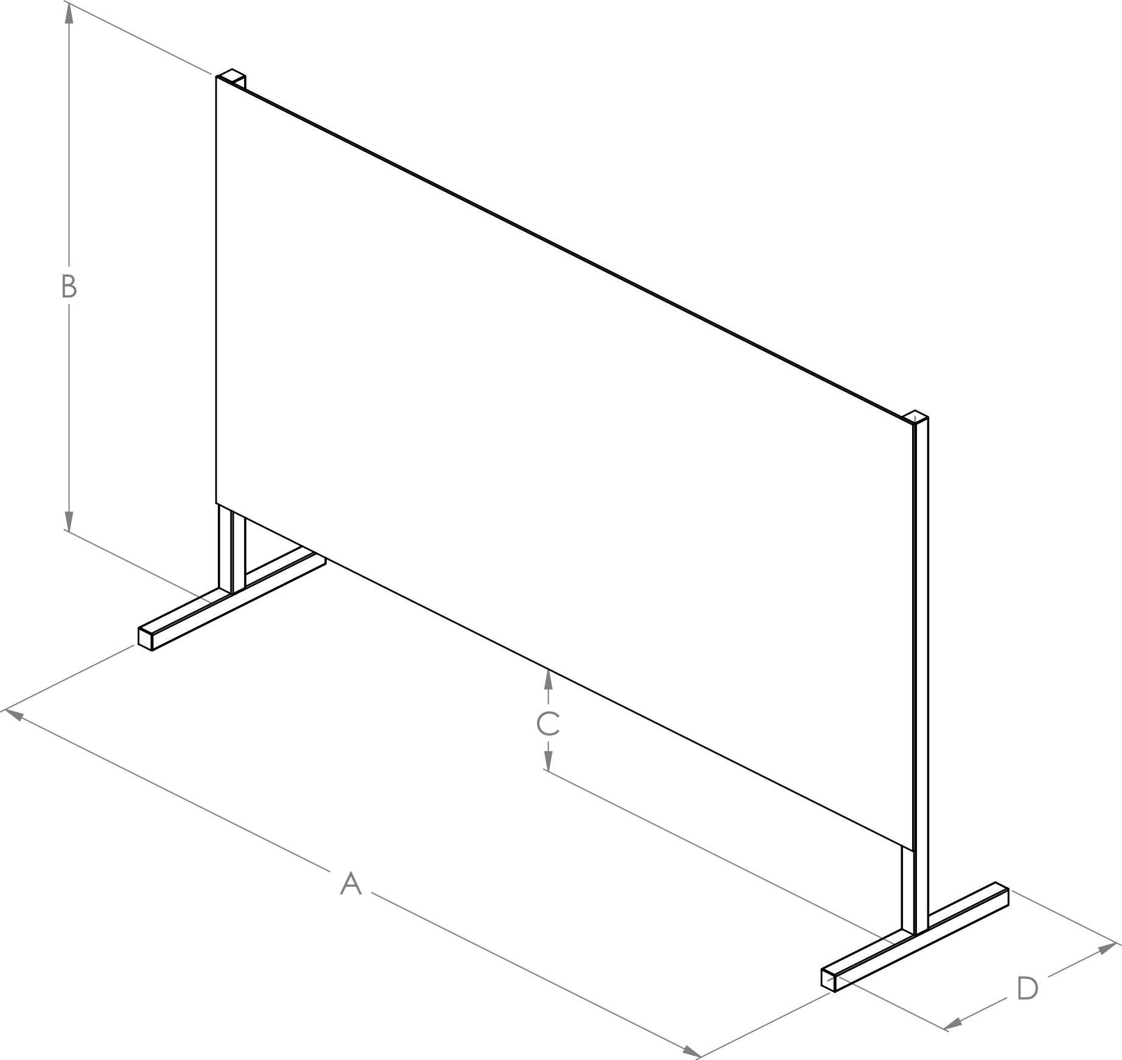

MISURE STANDARD

A | B | C | D | PREZZO
62 | 50 | 12 | 25 | 40+IVA
62 | 100 | 12 | 25 | 60+IVA
62 | 120 | 12 | 25 | 75+IVA
80 | 50 | 30 | 30 | 50+IVA
80 | 100 | 30 | 30 | 70+IVA
80 | 120 | 30 | 30 | 85+IVA

